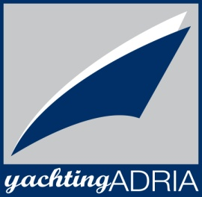
Sun Odyssey 39i, Ariel
Base | Marina Bar, Montenegro
Year built | 2009
Length | 11.7 m
Berths | 6 + 2
Toilets | 1
Water capacity | 355 l
Fuel capacity | 130 l
Sails | Roll, 2015
Engine | Yanmar 40 HP
Bow thruster | Yes

YachtingAdria
85000 Bar, Montenegro
+382 69 590 657
+381 63 692 287
+381 63 7769 525
office@yachtingadria.com
Yachtingadria
@YachtingAdria
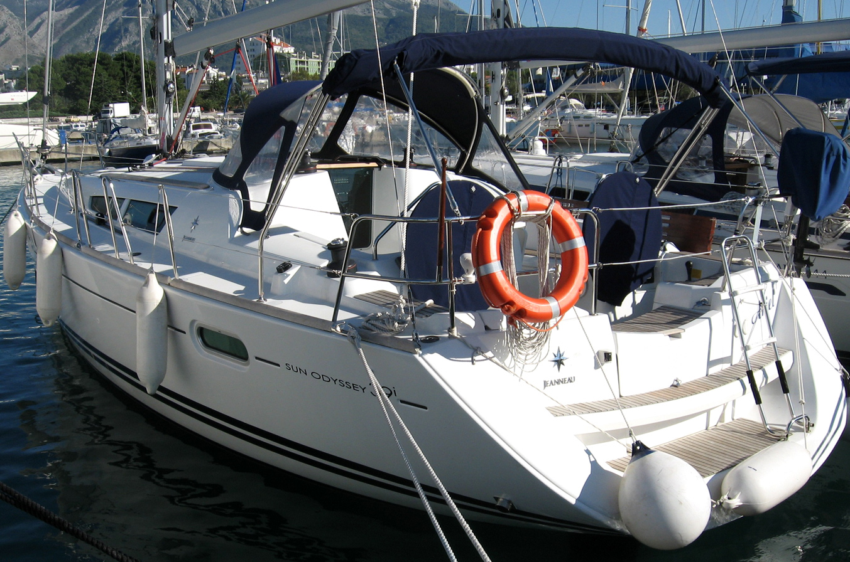

Deck equipment  Bow thruster, electric windlass, bimini top, sprayhood, deck shower, swimming ladder, teak cockpit, cockpit table, cockpit speakers | Safety equipment  life jackets, life raft, 1 horseshoe life buoys, radar reflector, distress flare box, first aid kit, fire extinguisher, fog horn, safety harness
Navigational equipment  VHF, Tri data, auto pilot, GPS plotter, radar, sea charts and pilot book | Other equipment  refrigerator, stove with oven, LCD/DVD/CD/MP3
