Base | Marina Lazure, Montenegro
Year built | 2006
Length | 14.99 m
Berths | 10+1
Toilets | 3
Water capacity | 650 l
Fuel capacity | 320 l
Sails | Roll
Engine | Volvo D2 75 HP
Bow thruster | Yes
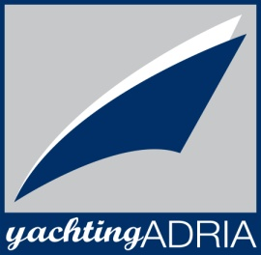
Bavaria 50 Cruiser, Dami

YachtingAdria
Marina Lazure, Montenegro
+382 69 590 657
+381 63 692 287
+381 63 7769 525
office@yachtingadria.com
yachting_adria
@YachtingAdria

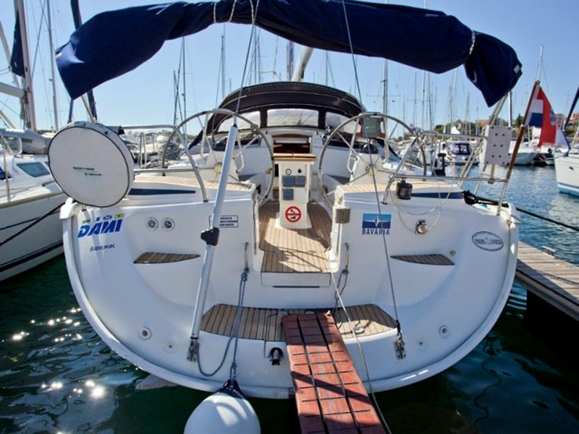

Deck equipment  Bow thruster, electric windlass, bimini top, sprayhood, deck shower, teak cockpit, cockpit table, cockpit speakers | Safety equipment  life jackets, life raft, 1 horseshoe life buoys, radar reflector, distress flare box, first aid kit, fire extinguisher, fog horn, safety harness
Navigational equipment  VHF, Tri data, wind instrument, auto pilot, GPS plotter in cockpit, sea charts and pilot book | Other equipment  refrigerator + ICE BOX, stove with oven, LCD/DVD/CD/MP3/USB
