Oceanis 45, Stella
Base | Marina Lazure, Montenegro
Year built | 2014
Length | 13.85 m
Berths | 8 + 1
Toilets | 2
Water capacity | 530 l
Fuel capacity | 200 l
Sails | Roll
Engine | Yanmar 54 HP
Bow thruster | Yes

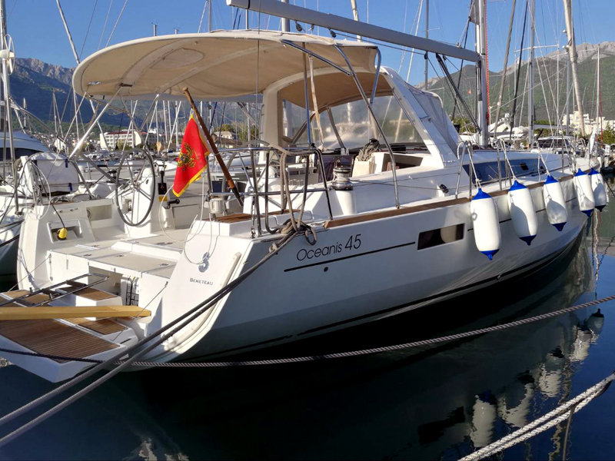

Deck equipment  Cockpit anchor control, electric windlass, bimini top, sprayhood, deck shower, swimming ladder, cockpit table, cockpit speakers | Safety equipment  EPIRB, life jackets, life raft, 1 horseshoe life buoys, radar reflector, distress flare box, first aid kit, fire extinguisher, fog horn, safety harness
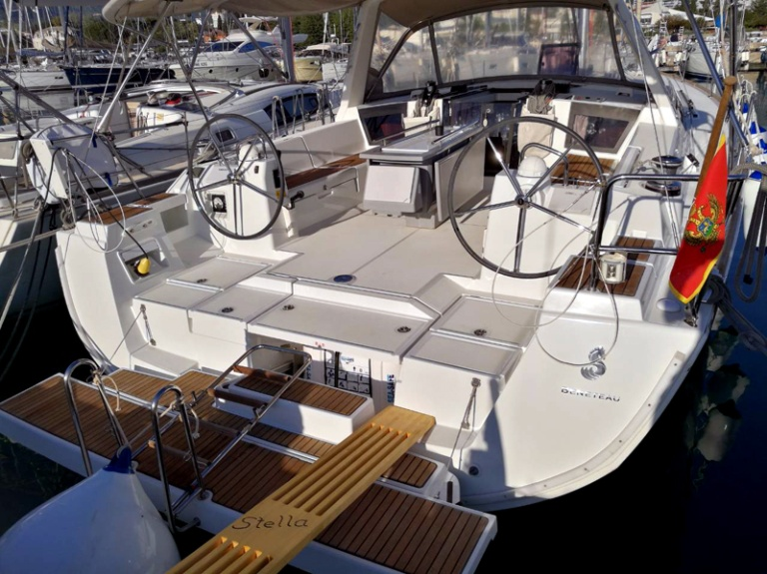  Navigational equipment  Vhf + mobile VHF, Tri data, wind instrument, auto pilot, GPS plotter (3 + 1 inside), radar, sea charts and pilot book | 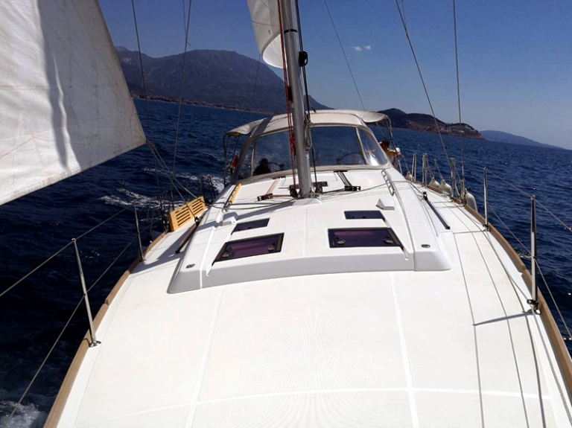  Other equipment  Fans in all cabins and saloon, heating, refrigerator + ICE BOX, stove with oven, LCD/DVD/CD/MP3/USB

